**Bank of codes (For Sonic Pi)**

**Play (number) (Piano bleeps)**

* Lower number - Lower pitched bleep
* higher number - Higher pitched bleep
* Use floats and integers

**Sleep (number) (pause)**

* Lower number - quicker pause
* higher number - longer pause
* Sleep 0.25 - shorter pause then - sleep 1
* Use floats and integers
* Note: Some sounds will play at same time if you do not put a sleep between them

**Amp (number) (loudness)**

* Lower number - softer sound
* Higher number - louder sound
* Use floats and integers

**Release (number) (how long the note goes for)**

* Lower number - quicker note hold
* Higher number - longer note hold
* Use floats and integers

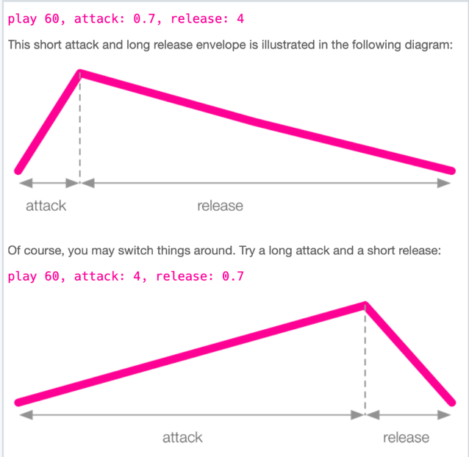

**Beat_stretch: (number)**

* Lower number - shorter beat stretch
* Higher number - longer beat stretch
* Use floats and integers

**sample :(name) (Sample tune)**

**Hashtag (#) to make that line readable but not involved in the coding**

**Use a :loop_sample in a live loop**

**Use_sample_bpm - keeps the bpm consistent so can overlay sounds ontop of sample**

**(number). times do -** put this above blocks of code to keep it going for a certain amount of times.

* For example: 3. Times do -goes through that block of code 3 times

**Sleep sample_duration :(sample name)** - Sleep will be however long the duration of the sample is so it keeps playing continuously with no pauses

**To use blocks of code - Use do for start and end for end**

* For example:

**Iteration and loops folder -** all about looping the tune/making it go for a specific amount of times

Put a **,** if I want to add new code features on the same line